NONLINEAR DYNAMICS IN CIRCUITS

Normally linear analysis is employed while dealing with circuits, and nonlinearity is treated as a distortion. This distortion is observed in harmonic generations, distorted signals etc. The standard approach is to linearize and analyze it by assuming weak nonlinearity. However, it is difficult to define the line between weak and strong nonlinearity. Strong linearity leads to completely irregular or chaotic behaviour. This, until recently, was considered an external noise, but with the advent of the chaotic phenomenon, it could no longer be overlooked. Let us consider the work done by Leon Chua in this field.

Leon Chua’s work



Leon Ong Chua is an American electrical engineer and computer scientist. He is a professor at the University of California, Berkeley and has done pioneering work in identifying nonlinear/chaotic behaviour circuits. From simple circuits using characteristics of certain circuit elements like negative resistance, he has been able to prove experimentally, numerically and analytically, almost all the features of a chaotic system.

*Chua’s Circuit:*

Chua’s circuit is a simple electronic circuit that exhibits chaotic behaviour. It is a non-periodic oscillator, i.e., it produces an oscillating waveform that, unlike an ordinary oscillator, never repeats. Leon O. Chua invented it in 1983, and its ease of construction has made it a ubiquitous real-world example of a chaotic system, leading it to be called *“a paradigm for chaos”.*

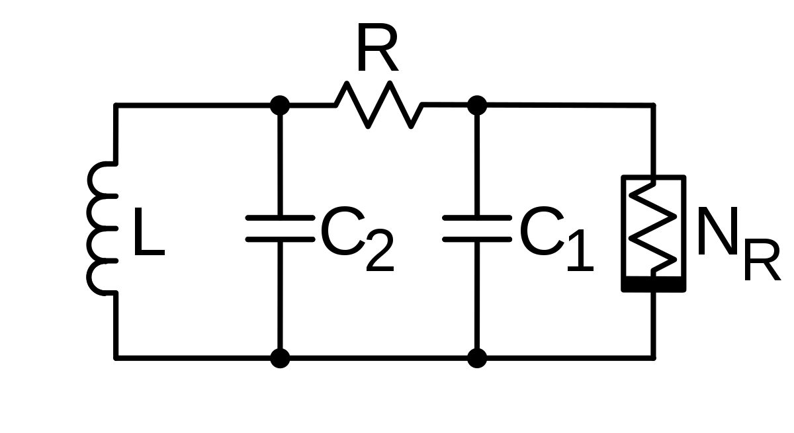Chua’s Circuit

*Chua’s Oscillator circuit consists of:*

* A linear Inductor L with a series resistance R0.
* A linear resistor R.
* Two linear capacitors, C1 and C2.
* A nonlinear resistor NR called *Chua’s Diode*.

*Chua’s Diode* has three-segment piece-wise linear driving-point characteristics. It is implemented as a voltage controlled, nonlinear negative resistor. A standard way to realize a Chua’s diode is by connecting two negative impedance converters in parallel.

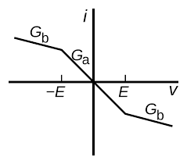i-V characteristics of Chua’s diode

Necessary Conditions for Chaos in Autonomous Electronic Circuits

A dynamical system described by two autonomous first-order differential equations can exhibit:

1. A D-C steady-state solution or
2. A Periodic steady-state solution

However, a third variable is necessary to exhibit a more complex steady-state solution. A linear circuit can show quasi-periodic motion. However, the underlying stretching and folding mechanism for generating chaos require nonlinearity. Therefore, from the point of view of circuit dynamics, the following conditions are necessary:

* One or more nonlinear elements.
* One or more locally active resistors.
* Three or more energy storage elements.

The active resistor supplies energy to separate trajectories; the nonlinearity provides folding, and the three-dimensional state space allows for persistent stretching and folding in a bounded region of the state space without violating the non-crossing property of trajectories. (Phase trajectories of an isolated system cannot cross)

Chua’s circuit is the simplest circuit meeting these criteria. The locally active resistor is a device that has negative resistance and is active (It can amplify), providing the power to generate the oscillating current. The locally active resistor and nonlinear element are combined in the Chua’s diode. The two capacitors and the inductor are the energy storage elements.

Analyzing the Chua’s Circuit

Chua’s circuit is analyzed using Kirchhoff’s circuit laws; its dynamics can be modelled using a system of three nonlinear ordinary differential equations in the variables x(t), y(t), and z(t), which represent the voltages across the capacitors C1 and C2 and the current in the inductor L respectively.

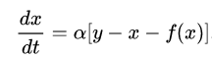

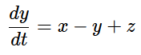 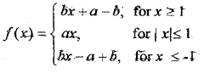

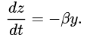

The function f(x) describes the electrical response of the nonlinear resistor, and its shape depends on the particular configuration of its components. The parameters α and β are used for this. A computer-assisted proof in Chua’s circuit showed a self-excited chaotic attractor, known as a “*double scroll*”, because of its shape in the (x, y, z) space.



Computer-Assisted Proof

Using a simple python program, we can easily solve the chaos in Chua’s circuit using the above equations. The code used is given below:

import numpy as np

from scipy.integrate import odeint

import matplotlib.pyplot as plt

# parameters

alpha = 15.395

beta = 28

R = -1.143

C_2 = -0.714

def chua(u, t):

x, y, z = u

# electrical response of the nonlinear resistor

f_x = C_2*x + 0.5*(R-C_2)*(abs(x+1)-abs(x-1))

dudt = [alpha*(y-x-f_x), x - y + z, -beta * y]

return dudt

# time discretization

t_0 = 0

dt = 1e-3

t_final = 300

t = np.arange(t_0, t_final, dt)

# initial conditions

u0 = [0.1,0,0]

# integrate ode system

sol = odeint(chua, u0, t)

# 3d-plot

fig = plt.figure()

ax = fig.add_subplot(111, projection='3d')

ax.set_xlabel('x')

ax.set_ylabel('y')

ax.set_zlabel('z')

ax.plot(sol[:,0],sol[:,1],sol[:,2])

plt.show()

which gives the following plot as result: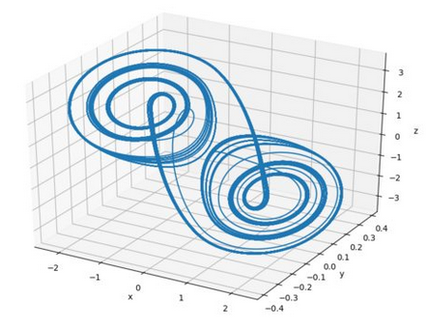

**Closing**

Chua’s circuit can be easily built using discrete components or a multilayer CNN (Cellular Nonlinear Network). The Chua’s diode can also be easily replaced by a memristor. One of its significant advantages is that the equations model the dynamical behaviour of the system quite accurately. Thus, by varying the parameters, we can study the nonlinear characteristics like Bifurcations, Self-similarities and Chaos.

**References**

*https://www.osti.gov/etdeweb/servlets/purl/20109628*

*https://en.wikipedia.org/wiki/Chua%27s_circuit*